News +++ SPS
Nuremberg, 24–26 November 2026

Inspiration, Innovation, and Interaction: The SPS 2026 Promises an Impressive Exhibitor Line-up and Curated Program
Stuttgart, 21 May 2026. The six-month countdown is on: From 24 – 26 November 2026, the global automation industry will again be out in full force at the SPS – Smart Production Solutions in Nuremberg. The exhibition has already attracted considerable interest, with more than 900 companies already registered, matching last year’s strong figures. The high proportion of returning exhibitors and number of newly registering companies clearly demonstrates the SPS’s enduring attraction as the leading exhibition for the automation industry.
“The strong exhibitor figures so many months before the event underscore the SPS’s relevance for the automation community,” says Sylke Schulz-Metzner, Vice President SPS at Mesago Messe Frankfurt. “Especially at a time of vast technological changes – industrial AI, data-driven manufacturing and fully networked systems to name just a few – the SPS has become an indispensable platform for information, interaction, and innovation. It shines a light on the solutions that will enable companies to build a smarter, more efficient, and more sustainable industrial future and brings together the people, ideas, and technologies responsible for making this happen.”

Focus on core industry topics
In addition to the varied exhibitors in attendance, speakers across four presentation stages will be sharing firsthand knowledge and practical insights into core industry topics such as industrial AI, cybersecurity, and digital transformation. Through subject-specific talks, best practice demonstrations, and panel discussions, experts will present real-world use cases, provide context on the latest trends, and share insights to help companies navigate the challenges of industrial transformation. To round out the program, guided tours will give visitors an opportunity to explore specific topics and interact directly with relevant providers.

Hands-on opportunities for young talent
The SPS offers young people a wide range of opportunities to experience automation firsthand and make their first industry connections. High school and university students, as well as recent graduates, will find specialized programs across all three days that blend education, hands-on experience, and networking.
Active participation is what the Makeathon is all about. Working together in small teams, the young people will tackle real-world industrial engineering challenges under tight deadlines, gaining valuable insights into modern automation solutions. Guided tours are also available for young people, helping them navigate the expo floor by topic and discover more about specific technologies and companies. Finally, the Young Talents Rallye offers the young attendees a fun, interactive way to explore the exhibition and meet exhibitors.

Expo news and registration
For all relevant details regarding the SPS, visit the official event website, sps-messe.com, which is regularly updated with new content and information about this year’s event. The up-to-date list of registered exhibitors as well as their product and solution portfolios is already available here. The ticket shop is also live, with discounted early-bird rates available until mid-October.

Year-round information hub for the automation industry
As a year-round platform, the SPS delivers value far beyond the three-day exhibition in November. The SPS Automation Hub offers a broad portfolio of events, online formats, and services focused on the latest industry topics and designed to facilitate high-level dialog and connect key players in the automation sector. These include online events such as the Technology Talks on the final Thursday of each month or SPS Insights featuring the latest industry news, trends, and developments. For more information, check out the website.
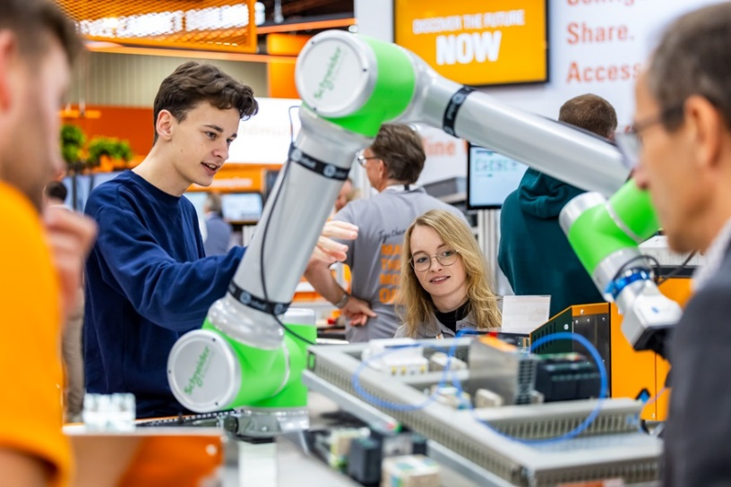
Copyright: Mesago Messe Frankfurt GmbH / Arturo Rivas
SPS
Smart Production Solutions – the 35th international trade fair for industrial automation
The SPS will take place from 24 – 26 November 2026.

Press information and photographic material:
Press - SPS

Links to websites:
SPS - Smart Production Solutions
https://www.facebook.com/spsmesse
https://www.linkedin.com/showcase/sps-smart-production-solutions/
https://www.instagram.com/spsmesse/

Your Contact:
Luise Werner
Phone: +49 711 61946-406
Luise.Werner@mesago.com
Mesago Messe Frankfurt GmbH
Rotebuehlstraße 83 -85
70178 Stuttgart
Germany
www.mesago.com

Background information on Mesago Messe Frankfurt GmbH
Since 1982, Mesago Messe Frankfurt GmbH has specialized in creating B2B formats for specific technology topics. Having originally emerged from the trade fair and congress sector, the company now offers much more than internationally established technology events. Thanks to the consistent development of its portfolio, Mesago connects leading players worldwide through innovative platforms in the form of industry-specific technology hubs, available 24/7, 365 days a year. Alongside traditional expos and conferences, these hubs comprise digital events, in-depth knowledge formats, and comprehensive services that are tailored to the specific requirements of individual industries.
These hubs create a dynamic space for a timely exchange of information and technological innovation, providing a year-round flow of content. With a view to the ever-changing needs of trade communities, Mesago creates ideal conditions through its forward-looking formats, primarily to further develop an even more efficient global network and to ensure that it is always up to date with the latest developments. This is true to the company's motto: 'Driving technologies by connecting bright minds'. As part of the Messe Frankfurt Group, Mesago employs around 170 people at its headquarters in Stuttgart, Germany. (mesago.com)

Background information on Messe Frankfurt
http://www.messefrankfurt.com/background-information

Sustainability at Messe Frankfurt
www.messefrankfurt.com/sustainability-information

