News +++ SPS
Nuremberg, 24–26 November, 2026

Analysis from SPS 2025: Automation industry focusing on growth and innovation
Stuttgart, 28 January 2026. At the end of 2025, the SPS – Smart Production Solutions once again captured the world’s attention in automation technology: 55,938 visitors, an increase of 9% on the previous year, took this chance to learn more about the latest developments in industrial automation from the 1,175 exhibitors on hand. Across 122,000 square meters of total presentation space, it became clear how heavily the industry is investing in technologies to make production more efficient, flexible, and interconnected. The event sent out clear signals for the future – for the mood of the market, the use of industrial AI, and the direction in which industrial automation is trending.
As the pace-setter of the automation industry, the SPS shows what future-oriented industrial automation can already achieve today and which technologies will be crucial tomorrow. The trade fair presents a full range of relevant topics, from intelligent control to interconnected industry. Meanwhile, participating in the SPS enables companies to stake out a clear position at the forefront of technological progress. The event’s importance for the industry is also reflected in the feedback it has received from exhibitors: 93% rate the SPS as important or very important for their company, and 88% are satisfied or very satisfied with their participation.
“The SPS is the most important live marketplace for automation; there’s nothing else like it in the world. This is where decision-makers and innovators meet to see where the technology will be heading in the coming years,” declares Steffen Winkler, CSO of the Automation business unit at Bosch Rexroth.
Eric Halvorson, senior marketing technology manager at DigiKey, adds: "The SPS is the leading meeting place for industrial automation, bringing together manufacturers, innovators, and collaborators in the heart of Germany. Even in challenging times, it sparks new ideas, partnerships, and opportunities for growth and innovation."
And Katharina Lange, head of marketing at ROSE Systemtechnik GmbH, sums it up succinctly: “The SPS isn’t only the annual highlight of the industry; for us, it’s also the most important and pioneering trade fair for the year ahead."

International participation continues to increase
The proportion of international exhibitors reached 44% in 2025, surpassing the previous year (40%). Behind Germany, China, Italy, and Switzerland were among the largest exhibiting nations. Fourth place was shared by Austria, Taiwan, and the USA, followed by the Netherlands. The proportion of international visitors remained unchanged at 29%, while the overall number of attendees increased once again. Austria, Italy, Switzerland, the Czech Republic, and the Netherlands were most strongly represented.

Visitor satisfaction at a consistently high level
The results of this year’s visitor survey tell an extremely positive story: 93% of those surveyed would visit the expo again, and 94% would recommend it to colleagues and customers. In addition, 90% rated the SPS as important or very important for their company, and an impressive 98% were satisfied or very satisfied with their visit to the trade fair. These figures are further illustrated by the visitors themselves, who summed up the importance and quality of the event as follows:
Victor Beverloo, solution architect at ASML, summarizing his visit to the trade fair: “It’s inspiring to experience innovations and emerging trends in such a tangible and impactful way.”
Kim Hindle, chief product officer at CareGo Tek, emphasizing the international dimension: “The SPS was an incredible way to see the latest and greatest in automation technology all in one place. A truly international coming together of the latest and greatest.”
Simon White, director at Farm Automation Australia, underscoring the trade fair’s strategic importance: "The SPS is a must-attend event for individuals and businesses looking to drive improvement, embrace innovation, and stay ahead of industry trends. It offers a unique glimpse into the future of our industries.“

Stages prove highly popular
The figures for the 2025 lecture program illustrate the importance of knowledge-sharing at the trade fair to impressive effect, with a total of 5,708 participants taking the chance to learn more in 182 presentations across four stages. Whether expert lectures, innovation-driven product presentations, or practical panel discussions, the stages offered visitors a wide range of opportunities to deepen their expertise and find out about current developments and trends in the industry. In particular, the 23 contributions on industrial AI met with great interest and enabled trade visitors to dive into this focus topic alongside the trade fair’s myriad booths.
The attached analysis of the SPS 2025 provides additional detailed insights into how the trade fair’s exhibitors and visitors break down.

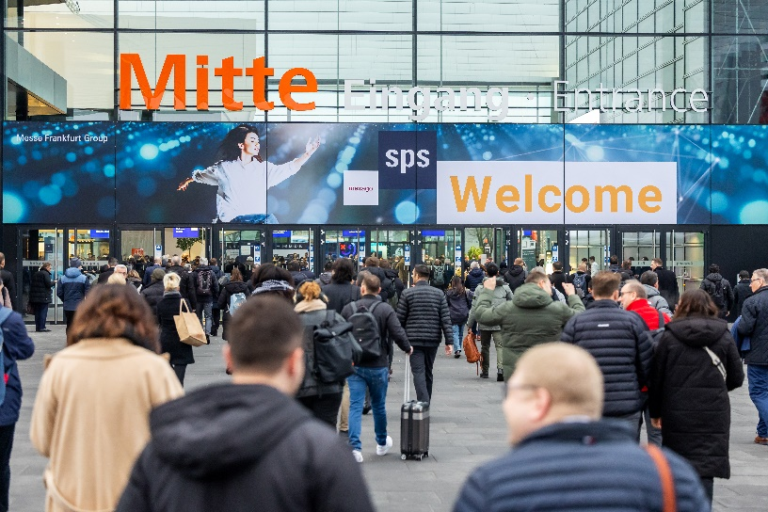
Copyright: Mesago Messe Frankfurt GmbH / Arturo Rivas
SPS
Smart Production Solutions – the 35th international trade fair for industrial automation
The SPS will take place from 24–26 November 2026.

Press information and photographic material:
Press - SPS

Links to websites:
SPS - Smart Production Solutions
https://www.facebook.com/spsmesse
https://www.linkedin.com/showcase/sps-smart-production-solutions/
https://www.instagram.com/spsmesse/

Your Contact:
Luise Werner
Telefon: +49 711 61946-406
Luise.Werner@mesago.com
Mesago Messe Frankfurt GmbH
Rotebuehlstraße 83 -85
70178 Stuttgart
Germany
www.mesago.com

Background information on Mesago Messe Frankfurt GmbH
Since 1982, Mesago Messe Frankfurt GmbH has specialized in creating B2B formats for specific technology topics. Having originally emerged from the trade fair and congress sector, the company now offers much more than internationally established technology events. Thanks to the consistent development of its portfolio, Mesago connects leading players worldwide through innovative platforms in the form of industry-specific technology hubs, available 24/7, 365 days a year. Alongside traditional expos and conferences, these hubs comprise digital events, in-depth knowledge formats, and comprehensive services that are tailored to the specific requirements of individual industries.
These hubs create a dynamic space for a timely exchange of information and technological innovation, providing a year-round flow of content. With a view to the ever-changing needs of trade communities, Mesago creates ideal conditions through its forward-looking formats, primarily to further develop an even more efficient global network and to ensure that it is always up to date with the latest developments. This is true to the company's motto: 'Driving technologies by connecting bright minds'.
As part of the Messe Frankfurt Group, Mesago employs around 170 people at its headquarters in Stuttgart, Germany. (mesago.com)

Background information on Messe Frankfurt
http://www.messefrankfurt.com/background-information

Sustainability at Messe Frankfurt
https://www.messefrankfurt.com/frankfurt/en/press/boilerplate.html#sustainability

