News +++ SPS
Nuremberg, 25 – 27 November 2025

SPS 2025 impresses with strong visitor response and powerful innovations
Stuttgart, 27 November 2025. The global automation community has just finished gathering for the industry’s annual highlight. From 25 – 27 November 2025, the Nürnberg Messe exhibition center once again transformed into the international meeting place in automation. The SPS – Smart Production Solutions 2025 made another strong impression, as well: Across 15 exhibition halls, 1,175 exhibitors presented their solutions for smart and digital automation. With around 56,000 trade visitors, the fair recorded significant increase compared to the previous year – a clear sign of the relevance and innovative strength of the event, sending a clear and positive signal for the future development of the automation industry.
The SPS is much more than just a space for product presentations, as this year’s event made evident once more. For three days, it offered an ideal setting for sharing ideas, obtaining practical insights, and engaging directly with innovative technologies. Visitors experienced how to combine theory and practice in meaningful ways, including through clear live demonstrations, in-depth specialist presentations, and personal discussions.
"The SPS offers the automation industry a platform not just for innovations, but especially for direct interaction. Experts came together again this year to work on solutions, discuss trends, and strengthen their networks. As in years past, the expo created a framework in which the community could continue growing on equal footing with a focus on real-world applications," Vice President SPS Sylke Schulz-Metzner offered in summary after three days at the trade fair.

Artificial intelligence a driving force
A key topic at the SPS 2025 was the increasing integration of artificial intelligence into industrial processes. Numerous exhibitors presented specific applications, from AI-supported quality inspection and adaptive control systems to intelligent maintenance solutions based on real-time data. Visitors were able to experience how AI can not only optimize individual processes, but rethink entire production systems, as well. On site, it became clear how important personal interaction will be in the further development of industrial AI.
“AI is already an integral part of many applications, and it’s also opening up countless possibilities for the future. Today, we’re seeing it used in all kinds of applications that have long since become normal in everyday life. At the same time, AI presents tremendous potential in new concepts that are currently still in the proof-of-concept phase – it’s an exciting glimpse of what’s coming” emphasizes Marcus Bliesze, Vice President Marketing for Automation, Siemens AG.

Knowledge platform and networking hub
In addition to industrial AI, the extensive presentation program at the four stages – which included the Technology Stage powered by VDMA/ZVEI – offered in-depth insights into other current topics in automation. In Meet the Speaker zones, visitors also had the opportunity to discuss specific questions directly with experts.

Meanwhile, the joint booth “Automation meets IT” (Hall 6) once again proved to be a significant draw. Conventional automation merged with modern IT solutions, resulting in an inspiring environment for exchange across various areas of expertise. The up-and-coming firms in the Start-up Area and at the “young INNOVATORS” booth also demonstrated to impressive effect how much creative energy and innovative power there is in the industry. The SmartFactory KL Guided Tours, which took place on all three days of the trade fair and introduced visitors to innovative technologies and applications, were particularly popular. The offerings at the SPS 2025 were rounded out by Thursday’s topic-specific guided tour on enclosure construction, which also met with considerable interest and provided valuable insights into current developments and best practices.

Day focus on cultivating the next generation
At the second SPS Makeathon, talented young attendees had the opportunity to work in interdisciplinary teams on tasks from real-world industry settings. On the final day of the fair, Young Talents Day also offered guided tours, career advice, and a rally with attractive prizes – a hands-on experience for school and university students, as well as those just starting their careers in automation.

Looking ahead
A detailed analysis with further results from the SPS 2025 will be published starting in early 2026. The 35th edition of the trade fair will take place in Nuremberg from 24 – 26 November 2026.

Meanwhile, the SPS also offers numerous opportunities to network with the community and stay informed about current trends in the automation industry all year round. The SPS Automation Hub enables technology enthusiasts to work together on digital solutions for the industry of tomorrow. More exciting content and opportunities for exchange are available through formats such as the monthly Technology Talks, SPS Insights (which provide current industry news), or the Industrial Technology Summits scheduled for 19 May 2026 in Stuttgart and 17 June 2026 in Leipzig.

Further information on the SPS, the SPS Automation Hub, and the formats available throughout the year is available online at sps-exhibition.com.

Further statements
Gerd Hoppe, Corporate Management, Beckhoff Automation:
“The SPS is a place where innovations in automation become tangible. Here, experts and customers come together to develop ideas and discuss new approaches to utilizing AI and other digital tools. Instead of waiting for others to do it for us, we want to play an active role in shaping these technologies. That sharing of ideas is exactly what makes the trade fair so valuable.”

Steffen Winkler, CSO Business Unit Automation, Bosch Rexroth:
“Automation is the technology that keeps our world running – from the microchip factory to the charging station. Anyone who wants to experience the future live and up close will find a real-life lab that presents AI, robotics, and software in a concentrated format at the SPS.”

Felix Kranert, Vice President Marketing DACH, Schneider Electric:
“The SPS is a fixture on the automation industry’s calendar. If you don’t exhibit here, you don’t exist! Meanwhile, it doesn’t just offer maximum visibility; it’s an environment where key ideas are shared, which is indispensable in challenging times.”

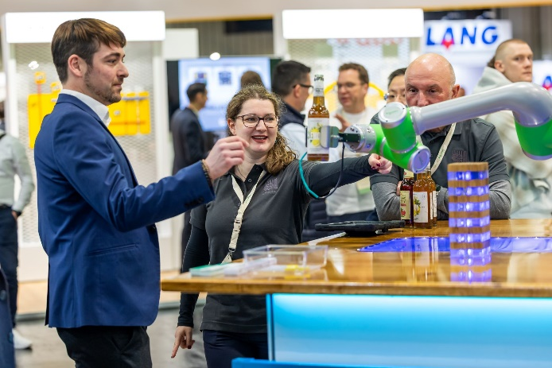
Copyright: Mesago Messe Frankfurt GmbH / Arturo Rivas
SPS
Smart Production Solutions – the 35th international trade fair for industrial automation
The SPS will take place from 24 – 26 November 2026.

Press information and photo material:
Press – SPS

Website links:
SPS - Smart Production Solutions
https://www.facebook.com/spsmesse
https://www.linkedin.com/showcase/sps-smart-production-solutions/
https://www.instagram.com/spsmesse/

Your contact:
Luise Werner
Telefon: +49 711 61946-406
Luise.Werner@mesago.com
Mesago Messe Frankfurt GmbH
Rotebühlstraße 83 -85
70178 Stuttgart, Germany
www.mesago.com

About Mesago Messe Frankfurt GmbH
Since 1982, Mesago Messe Frankfurt GmbH has specialized in creating B2B formats for specific technology topics. Having originally emerged from the trade fair and congress sector, the company now offers much more than internationally established technology events. Thanks to the consistent development of its portfolio, Mesago connects leading players worldwide through innovative platforms in the form of industry-specific technology hubs, available 24/7, 365 days a year. Alongside traditional expos and conferences, these hubs comprise digital events, in-depth knowledge formats, and comprehensive services that are tailored to the specific requirements of individual industries.
These hubs create a dynamic space for a timely exchange of information and technological innovation, providing a year-round flow of content. With a view to the ever-changing needs of trade communities, Mesago creates ideal conditions through its forward-looking formats, primarily to further develop an even more efficient global network and to ensure that it is always up to date with the latest developments. This is true to the company's motto: 'Driving technologies by connecting bright minds'.
As part of the Messe Frankfurt Group, Mesago employs around 170 people at its headquarters in Stuttgart, Germany. (mesago.com)

Background information on Messe Frankfurt
www.messefrankfurt.com/background-information

Sustainability at Messe Frankfurt
www.messefrankfurt.com/sustainability-information

